
Follow along with us as we cruise onboard our
56' Ocean Yacht.
Somewhere on the Water
Wednesday, August 13, 2025
Cat Head Bay anchorage to Frankfort, MI Municipal Marina

Welcome! Glad to have you here!

Last night, we had a thunderstorm, and the wind caused the waves to crash loudly against Valkyrie throughout the night. We had to close the windows in our room to keep the rain from blowing inside. I had hoped to catch a glimpse of the meteor shower that was supposed to peak overnight, but the weather simply did not cooperate. Between the storm and the scattered cloud cover, seeing the meteor shower just was not in the cards for me, nor was a good night’s sleep.
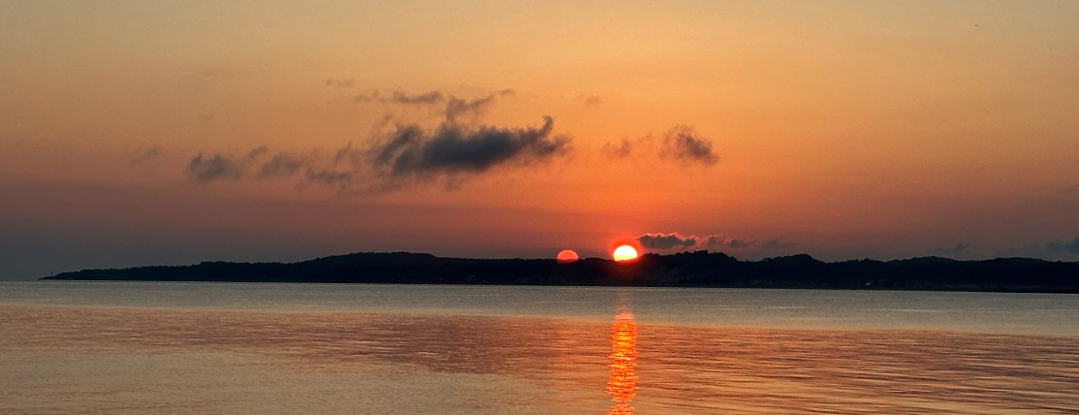
Mark took care of the anchor (per usual) as I stayed in bed trying to catch a few extra zzz’s. He called the Frankfort Municipal Marina to reserve a slip for us for today. Unlike some of the other MI marinas, this marina has a same-day reservation system. We had wanted to stop in Leland; however, we could not get reservations until the 19th. This is one of the more popular stops, and although we have found that advanced reservations have not been required so far this trip, Leland is one destination that should have been preplanned better, as well as Mackinac Island.
Our loop journey has been greatly influenced by the “Loopers Companion Guide” by Capt. John, who highlighted Leland as a favorite stop, and descrbed it as a Norman Rockwell painting. Anxious to get to Frankfort to get the new winch, we had to forego Leland and move on.

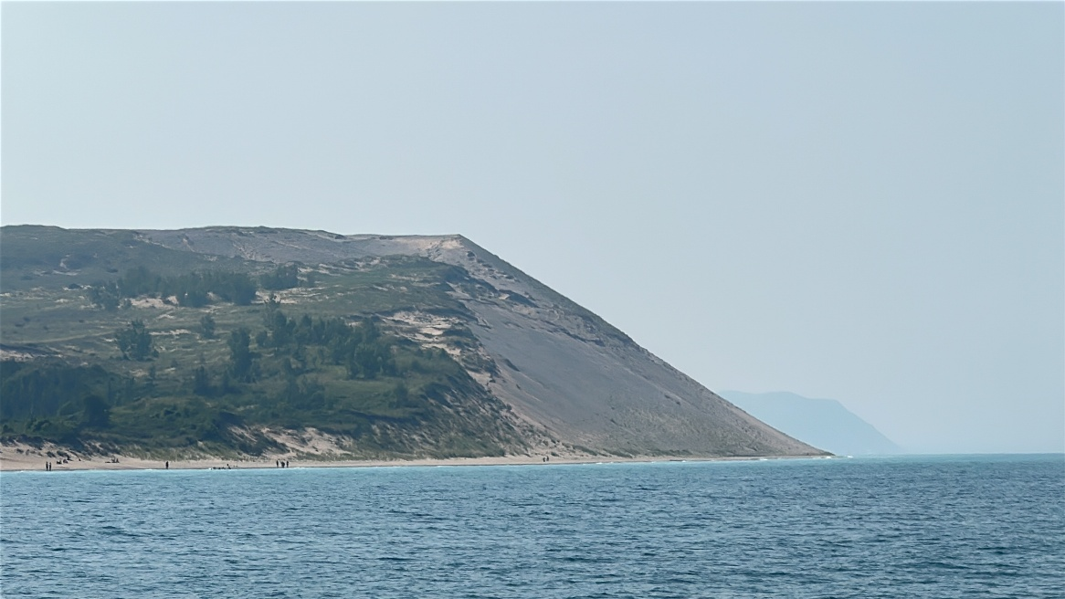

Sleeping Bear Dunes in Northern Michigan is the world's largest freshwater dune system. It features massive sand bluffs towering up to 400 feet above the turquoise waters of Lake Michigan, offering a unique blend of steep, challenging dunes, lush forests, and deep cultural history. (Reddit)
Reddit·r/NationalPark +5
Its standout features and highlights include:
- Record-Breaking Landscapes: It holds the title of the world's largest freshwater dune system, sculpted by ancient glaciers.
- The Dune Climb: A massive, steep wall of sand where visitors can race up the slopes or hike out to see panoramic views of Glen Lake.
- Pierce Stocking Scenic Drive: An iconic 7.4-mile driving route that features a covered bridge, scenic picnic spots, and overlooks framing unparalleled views of Lake Michigan and the Manitou Islands
- Deep Forests & Bluffs: Trails like the Empire Bluffs Trail lead visitors through old-growth forests to dramatic, 400-foot-high cliffs dropping directly into the lake.
- Rich Indigenous & Maritime History: The park's name is rooted in a local Anishinaabek legend. You can also explore historical outposts like the Glen Haven Historic Village, featuring preserved 1800s maritime stations and mills.
- Backcountry Island Adventures: The lakeshore encompasses North and South Manitou Islands, which offer remote wilderness, shipwrecks, and rustic camping

As we cruised along Lake Michigan towards Frankfort, swells picked up around 12:30 ish and were pushing us around a bit. Nothing too uncomfortable, luckily, just enough to remind us to keep everything inside secured.

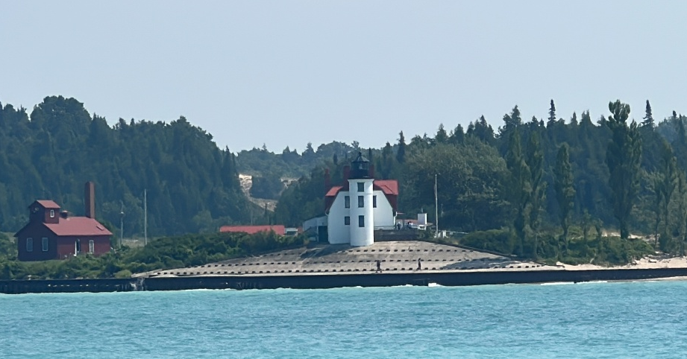
Point Betsie Lighthouse is located on the beautiful Lake Michigan shoreline south of the Sleeping Bear Dunes and north of Frankfort, Michigan. The original 1858 lighthouse, keeper’s residence, fog signal building, and Boathouse Museum are open to the public. https://pointbetsie.org/

Upon arrival at Frankfort, we stopped at the fuel dock and took on fuel before settling into our slip. Once again, the portside tie-up proved to be less than ideal because our portside electric cord did not reach the pedestal. Starboard cord to the rescue again. This is a bow-in dockage, which for us has been a rare occurrence.
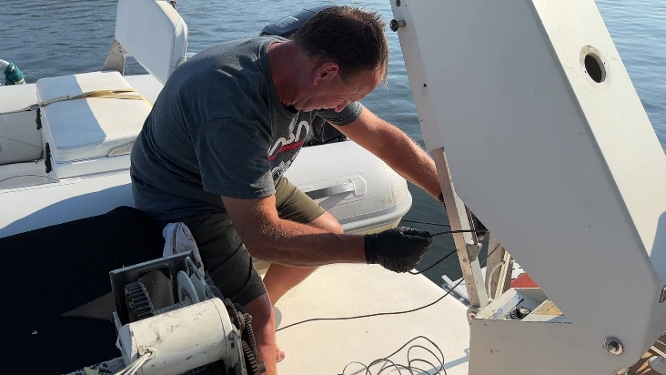
We are docked next to an Ocean Yachts 1988 fishing boat. It is in very nice shape and was kind of fun to be next to another Ocean Yachts. Captain Bob came out to introduce himself (he is from WI), and…while I was typing this, another Ocean Yachts fishing boat went by.
While I was busy with work, Mark went to the flybridge to prep for tomorrow’s task of installing the new winch.

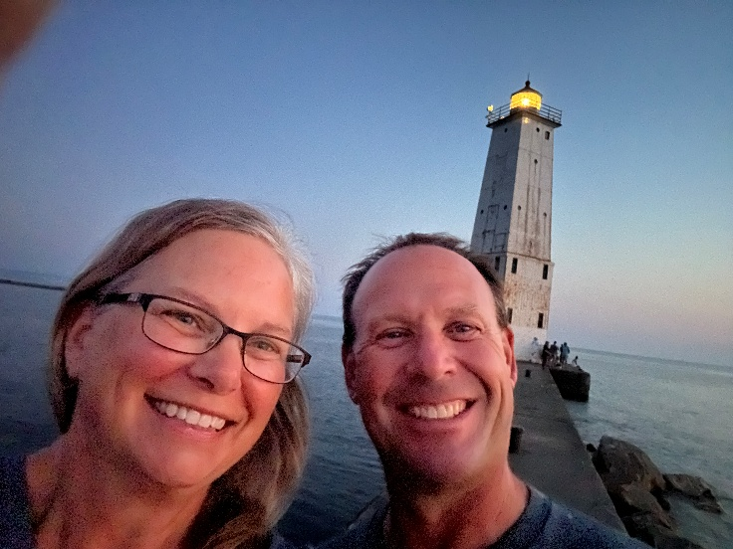
After dinner (leftovers), we went for a walk down to the beach, along the breakwater to the lighthouse. We dropped our old tattered American flag at the American Legion.
It was a beautiful summer evening, and we were not the only ones who took advantage of the magnificent evening and gorgeous view of the lake at sunset. We continued our walk along Main Street where we discovered several restaurants, drinking holes, and a couple of ice cream shops. Plus a variety of shops.

The Frankfort Light is a lighthouse located on the north breakwater in the harbor in Frankfort, Michigan. The current light was constructed in 1912 and placed on the National Register of Historic Places in 2005. Wikipedia

For more info on the lighthouse:
https://www.lighthousefriends.com/light.asp?ID=198
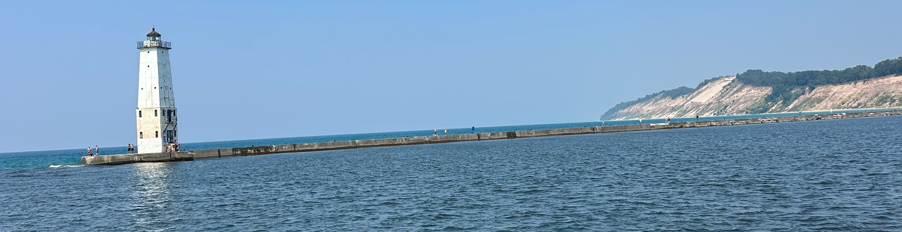

Daily Summary:
Departed from Northport Bay anchorage @ 8:23 am
Arrived at Frankfort, MI @ 2:25 pm
Hours traveled: 6 hrs 2 mins
Days cruised: 57 Days on the loop: 78
Nautical Miles Traveled: 46.75 for the day (1,400.34 total miles)
Average Speed 7.7 knots
Weather: Sunny and warm
Anchorage/mooring/marina review: Good hold, wavy due to storm & winds.
#of locks we went through: (73 total locks)


https://youtu.be/tgGOaSFDzBg

That is a wrap for this update!



Please don’t forget to LIKE & SUBSCRIBE to our YouTube channel!
Every subscriber helps us a lot! We appreciate it!



Time is unrenewable, and tomorrow is never promised, so do it before you can’t!

